Have you been the carer of someone with dementia?
Researchers from the SPHERE Knowledge Translation Strategic Platform are inviting carers to share their experiences in a “craftivist” research project.
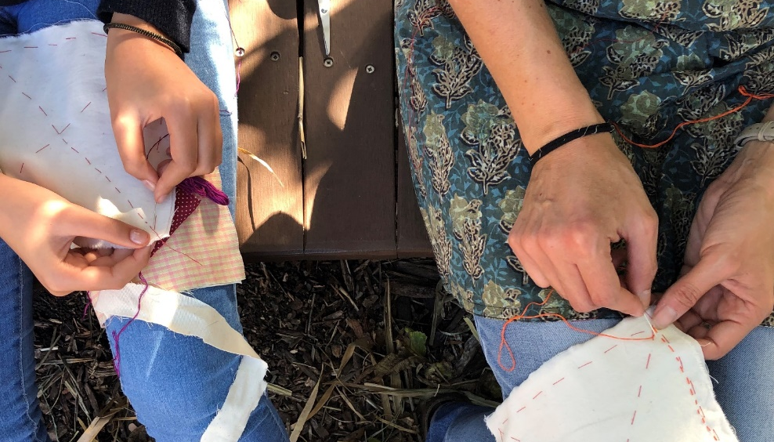
Please feel free to forward this invitation on to people who may be interested in participating, and/or your networks.

What is this about?

In this research project, we want to support you to craft and share important messages about your experience of caring for a loved one with dementia.
We found the term “craftivism” helpful to think about what we would like to do.

What is craftivism?

Craft + Activism = CRAFTIVISM
Craftivism is a gentle form of protest that appeals to people who might not identify as activists, but who still want to make a positive difference in the world about an issue that is important to them.
As “craftivists” we will use low tech processes like stitching, and easy to access materials like fabric and thread, to share important messages.
Sewing or drawing experience are not necessary for the workshops, and you will be guided through the various steps and processes by Michele Elliot, an experienced artist and facilitator.

What will I do?
- Participate in up to four, two-hour workshops at the Surry Hills Neighbourhood Centre, or you can also join remotely via Zoom
  - Workshop 1: Mon 12 April, 12:30-2:30pm
  - Workshop 2: Mon 26 April, 12:30-2:30pm
  - Workshop 3: Mon 10 May, 12:20-2:30pm
  - Workshop 4: Mon 24 May, 12:30-2:30pm
- Each session will be guided by artist and researcher Michele Elliot, who will lead participants through a series of tasks and open discussions.
- We will work together to decide where, and how, the work that is created can be shared.

Who can take part?
- Anyone who has a lived experience of caring for someone with dementia
- You must be 18+ years old
- You must be conversant in English
- You must have access to a private computer and internet
How can I take part?
To express your interest or find out more about the project, contact:
Name | Ms. Chloe Watfern
Position | Research Associate, SPHERE Knowledge Translation Strategic Platform
Telephone | 0406 484 429
Email | Chloe.watfern@unsw.edu.au

